**Jocelyn Fournier**

**Box 675**

**Ashcroft, BC V0K 1A0**

**Home: 250-457-3258**

**Cell: 250-467-2166**

**Business: 250-453-9309**

**E-mail: ghoshtakur@gmail.com**

**Profile**: Mature, responsible gentleman, with Level 3 First Aid certification seeking work as a **First Aid Attendant**.

**Skills & Qualifications:**

* Current Certificates: **OFA Level 3 (exp. 2014), WHMIS, Transportation of Dangerous Goods, H2S Alive, Petroleum Safety Training, Security Guard Basic Standard Training Level 1 and 2, Food Safe, Drivers Abstract**
* Grade 12 graduate; 2 years College
* Business owner for past 12 years
* Valid Class 5 Driver’s License, winter driving experience
* Avid outdoorsman, healthy, fit
* Prepared to relocate for employment

**Work Experience:**

**First Aid Attendant, OFA3-IPS and HSE,** Fort. Saint John, BC – August- September 2013

* Medic for Patterson 24, Natural Gas drilling site

**First Aid Attendant,** Canruss First Aid – Fort Neslon, BC (2011- 2012)

* Emergency medical care for workers at BC Hydro Project

**Owner,** Veggie Lunch at SFU – Burnaby, BC (1999 – 2011)

* Catered special events at the University
* Planned menus, purchased supplies and food, managed cash and cleaning duties

**Security Officer**, Securiguard Services – Vancouver, BC (2004)

* Liaised with Police and Fire Departments and responded to all emergency situations
* Answered radio pages and calls; maintained the safety and security of residents, visitors and staff
* Performed ID and vehicle checks

**Teacher**, ISKCON (International Society for Krishna Consciousness) – New York, Pennsylvania, and Florida USA (1980 – 1990)

* Cared for and taught children in Boarding School

**Resume of Jocelyn Fournier…Page 2**

**References:**

**Tim Moore,** Personal Reference and Oil Patch Medic(please see attached letter) – Ashcroft, BC Phone: 250-457-7186

**William Dean**, Personal Reference and Level 3 First Aid Attendant – Ashcroft, BC (Letter attached)

**Lawrence Jones,** General Office Coordinator, Simon Fraser Student Society – Burnaby, BC Phone: 778-782-3870 (Letter attached)

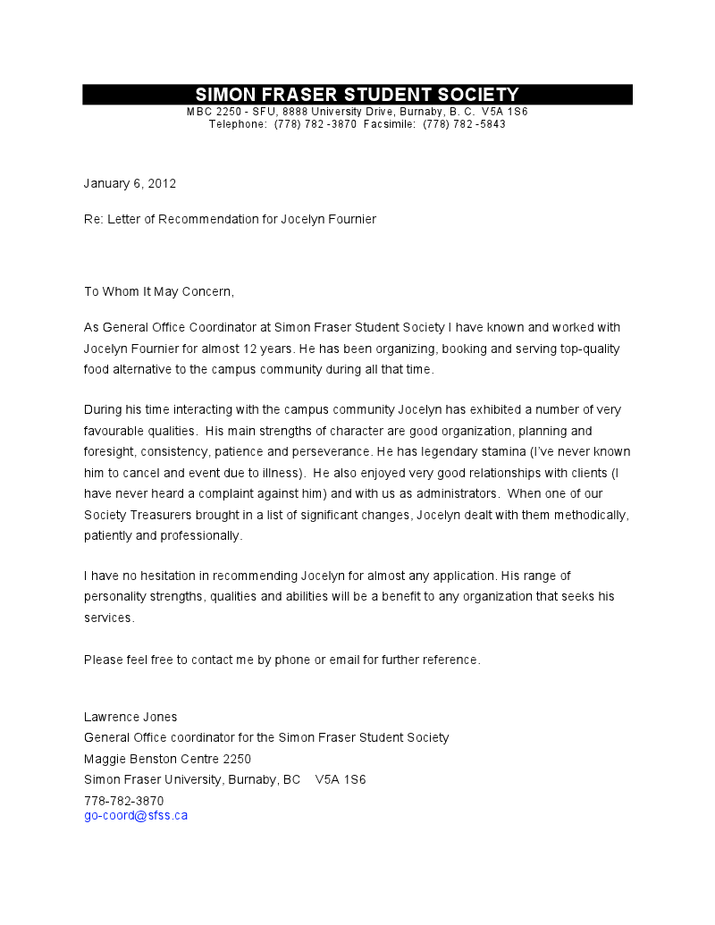

William Dean  
PO Box 704  
Ashcroft, BC  
  
To Whom It May Concern:  
  
I have been working as an OFA Level 3 First Aid attendant with Industrial Paramedics Services for the last two years. I have known Jocelyn Fournier as a friend and colleague for many years. I think his personal skills and talents uniquely qualify him as first aid attendant. He is thoroughly reliable and a man of outstanding character. He doesn't drink or take drugs. He and his wife of thirty years have very successfully raised a family of five. He is skilled with his hands and has proven his ability to manage his own business for over twelve years. He interacts well with both management and the public and is thoroughly trained as an OFA Level 3 First Aid Attendant. Therefore I can recommend Jocelyn without hesitation.  
  
Yours sincerely,  
William Dean

Time Moore

PO Box 326

Ashcroft B.C

(250)-457-7186

To whom it may concern:

Jocelyn Fournier has been my neighbor for the last 15 years. He is dependable, easy to get along with, and a hard worker. I have worked in the oil patch as a medic for the IPS (Industrial Paramedic Services) for the last two years. I believe Jocelyn is well suited for that type of work, I am sure he would be a valued employee.

Yours Sincerely,

Tim Moore

